Cloudformation Mini-Project

Step1

Deploy a Samplenetwork Configuration Stack

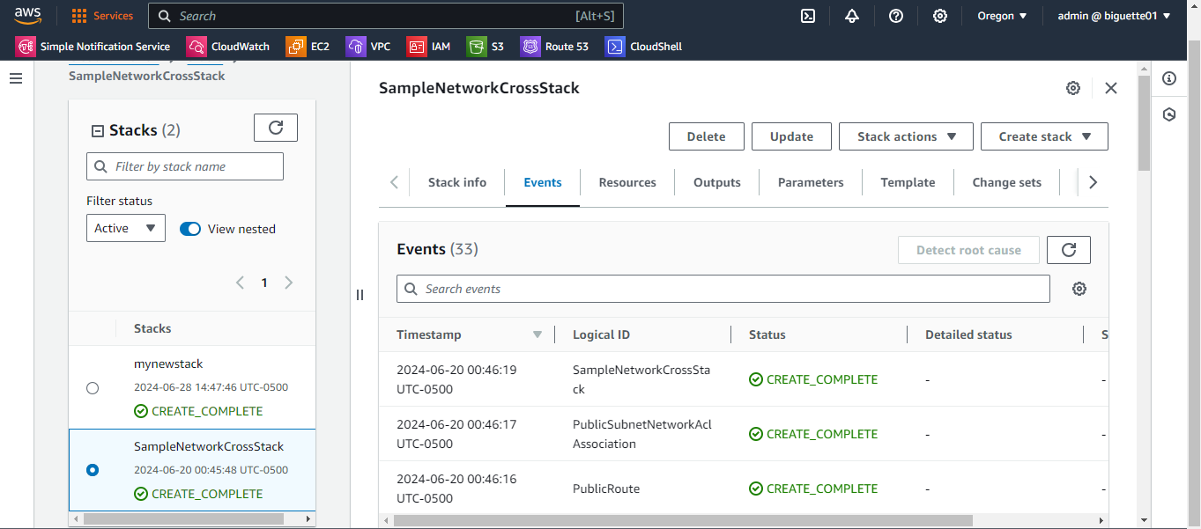

STEP2

* 1. Deploy a template in us-west-2 region

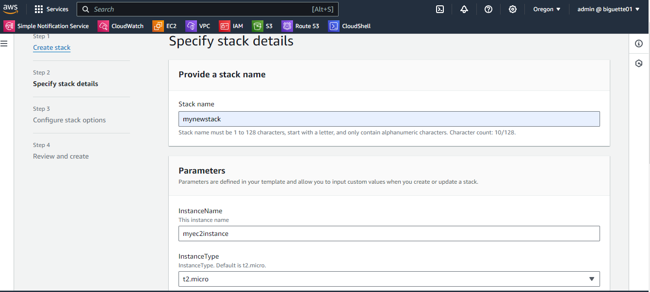

* 1. Elastic IP

Second Stack

2- Reference all available variable

Screenshot Of Apachee Message

3- Create a Mapping Fonction

4- Create a Parameters

5- Output values and the DNS name

